|  |  |
| --- | --- |
|  | **Rhosddu School Newsletter**  **February 2025** |

**Phonics Workshop**

On Friday 18th March at 2pm, Mrs. Hughes will be running a phonics workshop for parents and carers to find out more about the teaching of Phonics at Rhosddu Primary School. The workshop outlines what phonics is, how it helps your child with their early reading and writing, and provides a range of ideas for activities and resources you can use to support your child at home.  While this workshop is aimed at early readers, we welcome anyone who would like to come along to learn a bit more about Phonics and how you can support your child in their early reading and writing. The session will be run in the school hall with entrance through small blue car park gate. We look forward to seeing you there!

**Safer Internet Day**

 As a school, we celebrated Safer Internet Day (11th Feb) with a week of activities focused on raising awareness of staying safe online. There were several assemblies about being safe, including one led brilliantly by our digital leaders. The older children were also set a challenge to find ways to inform others about online scams and how to recognise them. The winners of the challenge will be announced shortly. Da iawn pawb!!

If you’d like to know more about keeping your child safe online The Welsh Government have produced a range of resources to support children with online safety and cover a variety of topics such as e-safety and online bullying: [Advice for children and young people: online issues and worries – Hwb](https://hwb.gov.wales/keeping-safe-online/advice-for-children-and-young-people-online-issues-and-worries/)

***Think You Know*** has support and advice for children and parents and from the National Crime Agency: [Online safety at home – Support and resources for parents and carers – Hwb](https://hwb.gov.wales/news/articles/b8862e72-5d6a-4022-938d-8f37977dc34c)

The NSPCC also have a wealth of information to help parents talk to children and advice on parental controls, sexting and online games: [Keeping children safe online | NSPCC](https://www.nspcc.org.uk/keeping-children-safe/online-safety/)

**Community Breakfast**

After the success of our last community breakfast, we would like to invite you to join us on the **8th of May at 9am** for the next one. Please join us for breakfast and an opportunity to chat to a range of different service who work with children and families across Wrexham.

**Communication**

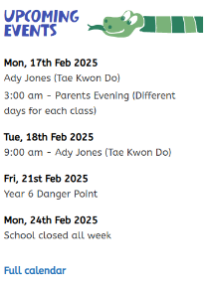We are working hard to improve our communication systems and would like to thank you all for supporting us with trying to become as paperless as we possibly can. Please can you ensure that if your email or telephone numbers change throughout the year you let the school office know so we can refresh our records and keep you up to date. Please also sign up to our school calendar which can be found on our School website.

Alongside all the other schools in Wrexham we have recently moved to a new data management system called Bromcom. As part of this we have access to a new school communication app that we hope to trial after half term- watch this space for more details!

**World Book Day**

 Once again, we will be supporting World Book Day and its mission to get everyone reading for pleasure. We know that some pupils really enjoy dressing up as their favourite characters, but for other families this is an expensive and stressful day. So this year, to help promote the '**Read Your Way'**theme, we are encouraging pupils who don't want to dress up, to come to school in their most comfortable clothes - onesies and PJs are welcome!

We will be having a whole school 'Book Swap' event in the afternoon. If your child has a book (or books) that they no longer want, they can bring them into school and swap each one for a 'new-to-you' book that they can keep and take home.

If you have any questions, please speak to your child's class teacher.

**School News**

**Criw Cymraeg:** On Friday 7th February we celebrated Dydd Mwsig Cymru/ Welsh Music Day! Pupils were introduced to modern, Welsh language music. The Criw Cymraeg organised music for gwasanaeth (service), amser snac (snack time) and amser cinio (dinner time). The Criw Cymraeg have received wonderful feedback from pupils and staff , who have enjoyed listening to new music.

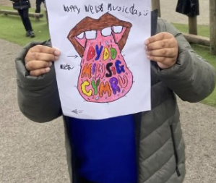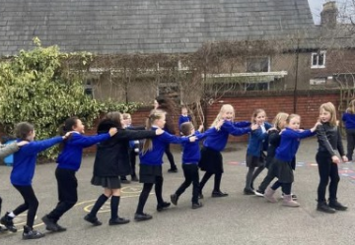

**Robinwood:** Year 6 had a fantastic time on their residential; they experienced lots of different activities, such as Archery, Canoeing, Caving and the Zip Line to name a few. We were so proud with how they conducted themselves throughout the trip, always being Ready, Respectful and Safe.

**Are Exhibition Year 5 and 6:** It was a real pleasure to invite parents, carers and also the Mayor and staff from Ty Pawb to attend our Year 5 and 6 Art Exhibition. The children were able to showcase all their Expressive Art pieces, which included work based on Rhiannon Roberts (Welsh Artist) who is well known for her colourful designs, as well as work from local Artist [Liaqat Rasul](https://eur02.safelinks.protection.outlook.com/?url=https%3A%2F%2Fwww.saatchiart.com%2Fen-gb%2Fliaqatrasul%3Fsrsltid%3DAfmBOopaIOKFh2QNw6FT9wKkf9Li1CqXTb1N6Mw17GE8on5nQt3uAbGc&data=05%7C02%7CHeadteacher%40rhosddu-pri.wrexham.sch.uk%7Cb80dbe3e85784abb367c08dd4c29e780%7C4f3f0e52b734416494091b601d147993%7C0%7C0%7C638750465032026106%7CUnknown%7CTWFpbGZsb3d8eyJFbXB0eU1hcGkiOnRydWUsIlYiOiIwLjAuMDAwMCIsIlAiOiJXaW4zMiIsIkFOIjoiTWFpbCIsIldUIjoyfQ%3D%3D%7C0%7C%7C%7C&sdata=ObO5qiLUkqO31a1PIzQu%2BPCQpFjEUFIZUYrHsP%2FPvZ0%3D&reserved=0). This was closely linked to the Autumn Term work on ‘Welcome to Wrexham’ and gave a real life ‘Authentic Context for their learning.



**We wish you all a very happy half term break full of fun! Please note the first day back at school is Monday 3rd of March- there is no INSET day.**

**Dates for Your Diary**

**March**

**Mon 3rd** School opens to pupils

**Thurs 6th**- World Book Day- see above

**Fri 7th** School Eisteddfod- children can wear national dress, something red, welsh team kits or Rainbow/Brownie/Guide Beaver/Cub/Scout Uniform

**Fri 21st** Phonics Workshop for parents- see above

**April**

**Thurs 3rd** Coch visit to Agrication

**Fri 11th** Easter egg hunt and break up for Easter

**Mon 28th** INSET school closed to pupils

**Tues 29th** School opens to pupils

**Weds 30th**- Tempest Reception and Year 6 photos

**May**

**Mon 5th-** Bank holiday school closed

**Thurs 8th-** Community Breakfast

**Fri 23rd** Break up for half term

**June**

**Mon 2nd** School opens to pupils

**Thurs 26th** Yr6 Common Transfer Day

**July**

**Thurs 3rd-** Sports Day- Infants am and Juniors pm

**Fri 4th**- Sports Day reserve date

**Fri 11th**- Sports Day 2nd reserve date

**Fri 18th** Break up for Summer