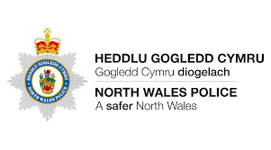

I DO / DO NOT (please circle) give North Wales Police consent to place an Identification Wrap on my child’s bike on the 22nd March 2024. I understand that this may leave a permanent mark on the bike which may not be removed.
To ensure the bike is protected should it be found or recovered, please register the bike, adding the location of the marking, on Immobilise.com. Immobilise is a property register used nationally by Police forces.
Child’s Name: |  | Class:
Parent’s Consent: |  | Date:

……………………………………………………………………………………………………………………………………………………………
PLEASE READ THE INFORMATION BELOW AND KEEP FOR YOUR INFORMATION.
For this event to run smoothly please follow the points below
- When? - 22nd March 2024
- Where? - On the top yard near the shelter starting at 3pm.
- The consent forms need to be in by the 18th March 2024 in order for us to have an idea of numbers.
- Children will need their bikes available on the 22nd March for the sticker shown below to be put on by the Police Force.

Many thanks for your continued support.
Mr Owen

