HOMEWORK GUIDE FOR PARENTS
Using a video and uploading a picture
Dear Parents/Carers,
The focus of the task this week is watching a video, working on paper, take a photograph of their work and upload it to the Google Classroom. All children have been able to do this in school using iPads, but obviously the steps may be a little different depending on what the children use at home. If the children use laptops, we find it is then easier to use a mobile to take a photo of the work and upload directly from there. You can transfer the photo to the laptop though and upload that way.

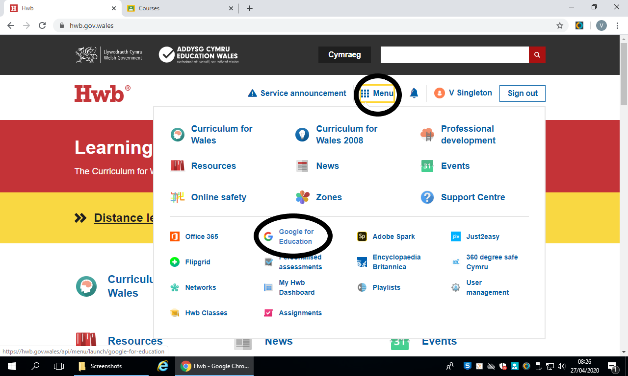 | 1. Google HWB.  2. Log into HWB using the log in details above. Your child has done this many times in school the last couple of weeks.  3. Click on the menu waffle (circled), then onto Google for Education (circled).  At this point, you may have to log in using your HWB email in a different window again.
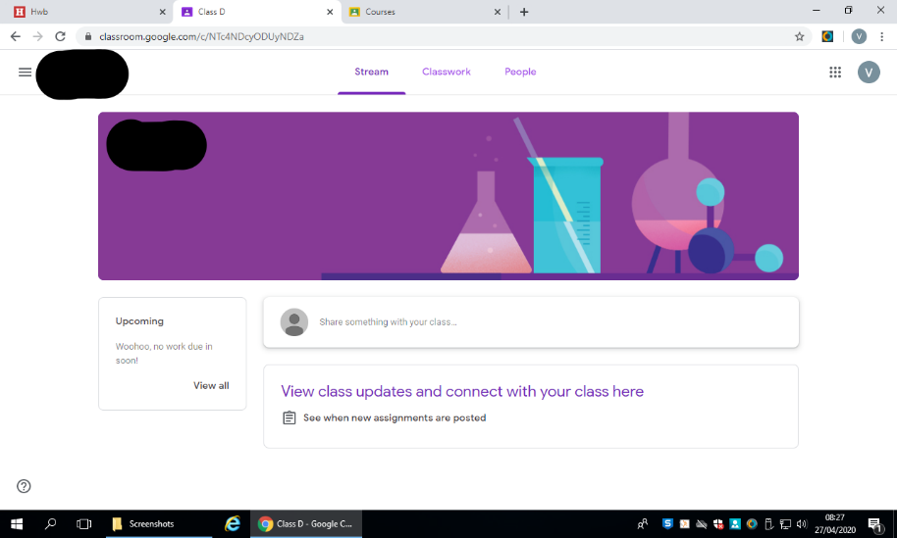 | This is your homepage (yours might be a different colour).  You have 3 tabs.  ‘Stream’ where you can chat.  ‘Classwork’ for where all your work will be stored.  ‘People’ to see who is in your class.
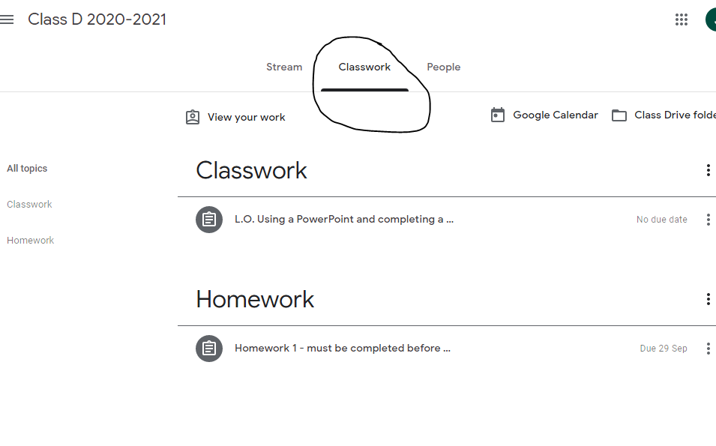 | 4. Click on ‘Classwork’ to see work that has been set for you.  Your homework will always be in the homework folder. Please do not complete any classwork at home.
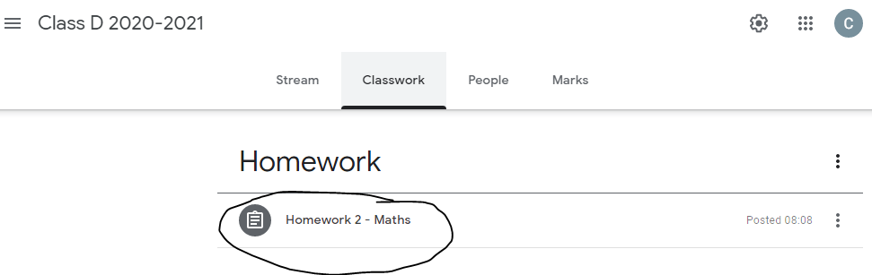 then 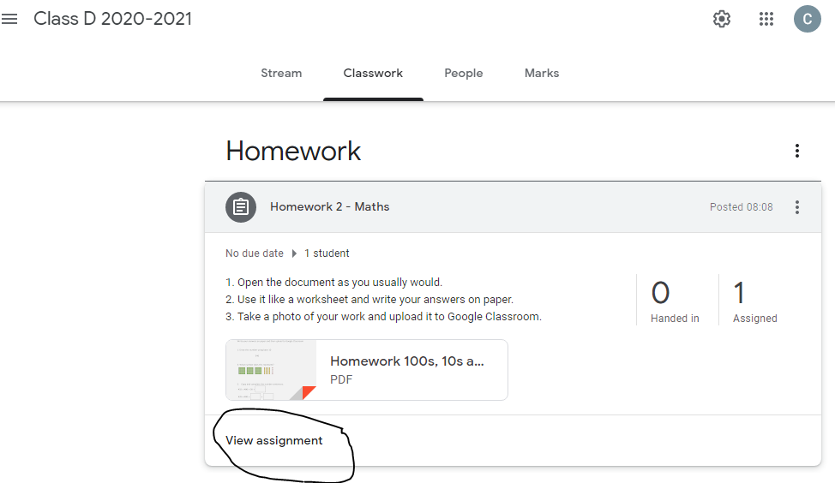 | 5. Click on the piece of work you need to complete then click view assignment.
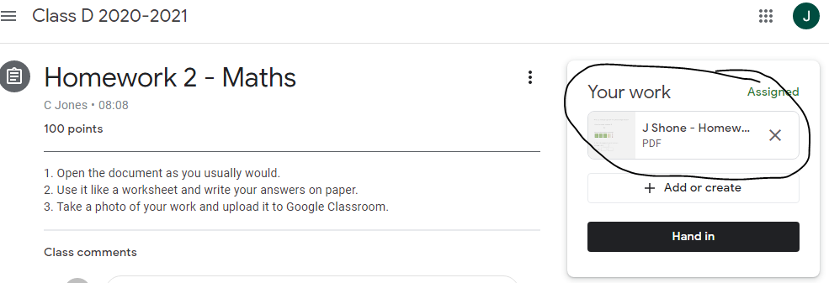 | 6. For this task, we have attatched a video that the children need to draw along with.
7. The children now need to take a picture of their work.

Tablet: If you are using a tablet then you should be able to take a photo and upload using the instructions below.
Mobile: If you are using a mobile then you should be able to take a photo and upload using the instructions below.
Laptop: If you are using a laptop then you can take a photo using a mobile or tablet and then either upload it directly from that device OR transfer the photo to your laptop and upload it from there. Follow the instructions below for both options.
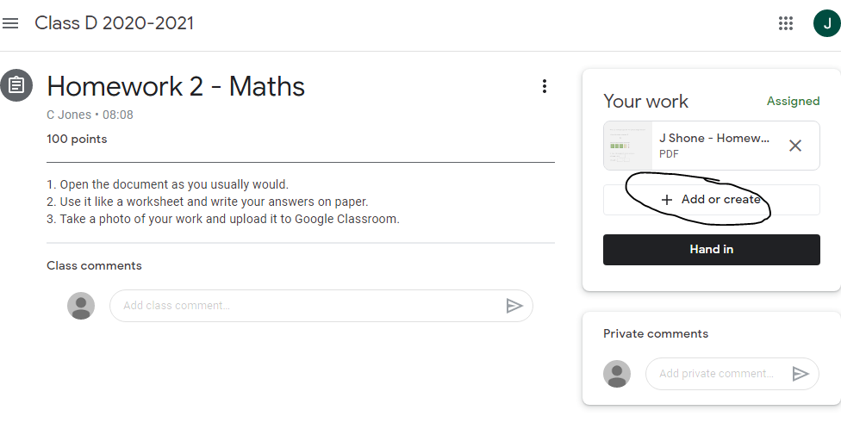 | 8. Return back to this page and click on ‘add or create’.  Select the photo and upoad it.
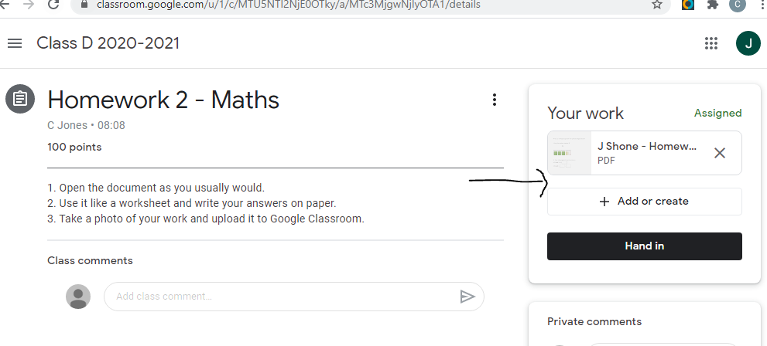 | 9. Your picture will appear in the space indicated by the arrow.  10. Then click ‘Hand in’ so that your teacher can see your work.

