Dear parents/carers,

In the Juniors we use Google for Education to provide blended learning instead of SeeSaw. The last couple of weeks the children have been taught how to access Google Classroom, however they might need some support from yourselves. We have put together a ‘How to guide’ to support the first task and will continue to send more instructions for other tasks. The focus for this task is opening and editing a Google Doc and then handing it in. We really appreciate your help.

Google for Education can be accessed through laptops, tablets and mobile phones via the internet. It can also be downloaded as an application on some devices.
1. Launch the internet on a device and get to the HWB homepage.
www.hwb.gov.wales

If you are using the Google for Classroom App, please skip step one and two and just log in using the children’s email and password provided.

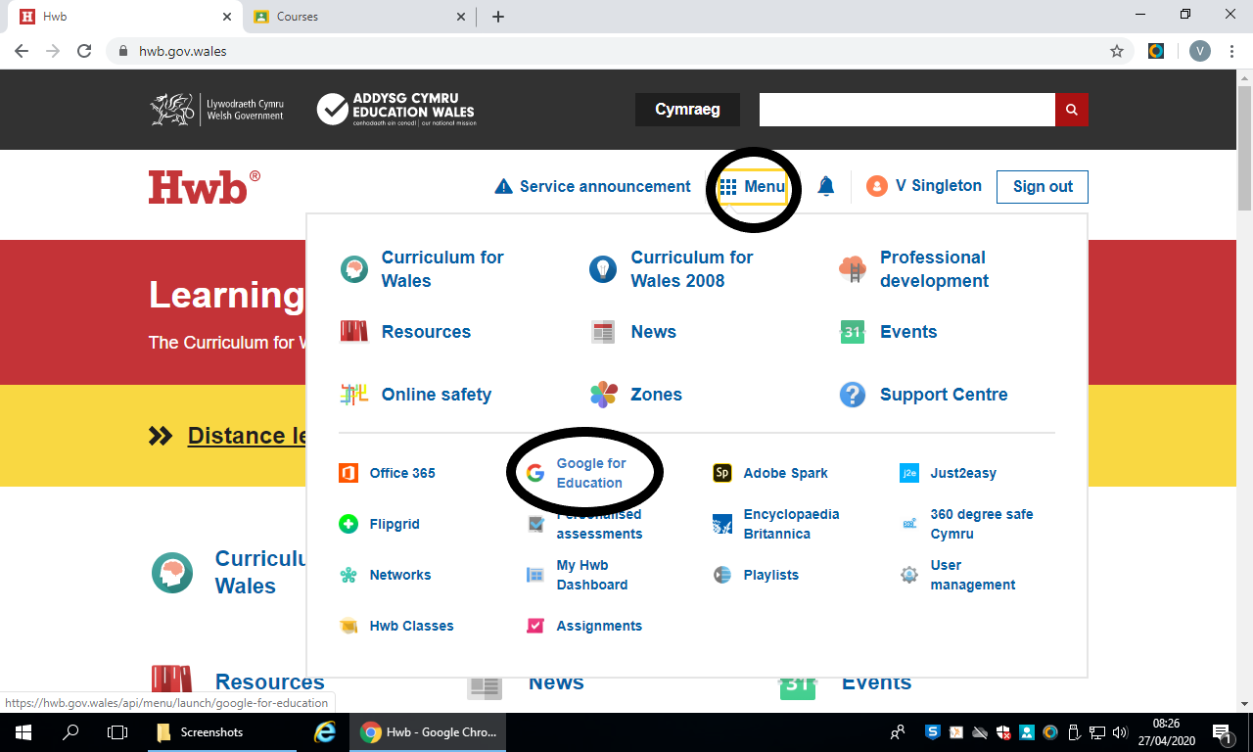 | 2. Log into HWB using the children’s email and password (see attached), click on the waffle, then onto Google for Education.  At this point, you may have to log in using your HWB email and password again.
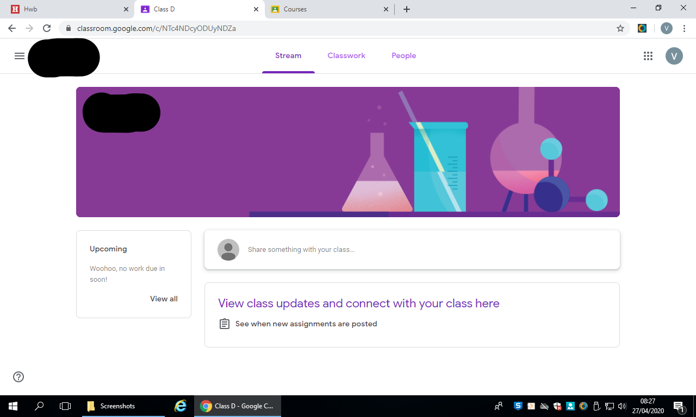 | This is your homepage. You have a ‘Stream’ where you can chat, ‘Classwork’ for where all your work will be stored, and ‘People’ to see who is in your class.
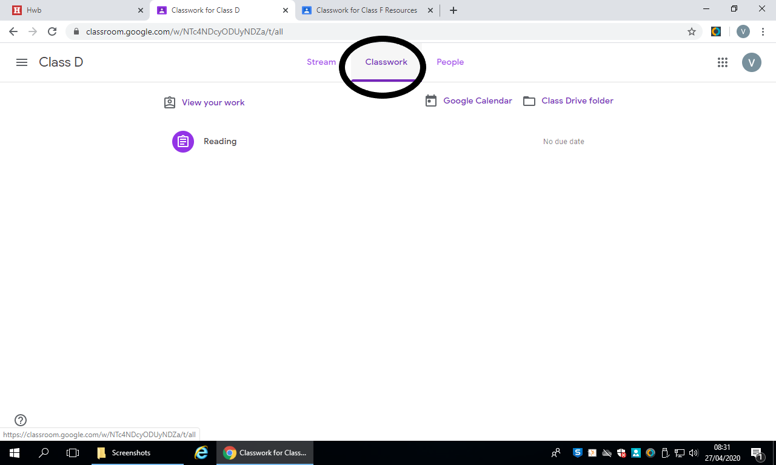 | 3. Click on ‘Classwork’ to see work that has been set for you.
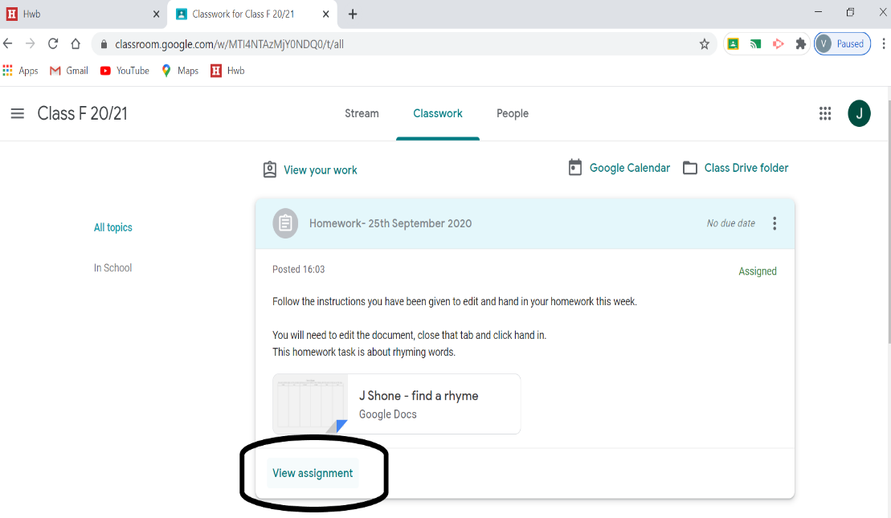 | 4. Click on the piece of work you need, then click view assignment.
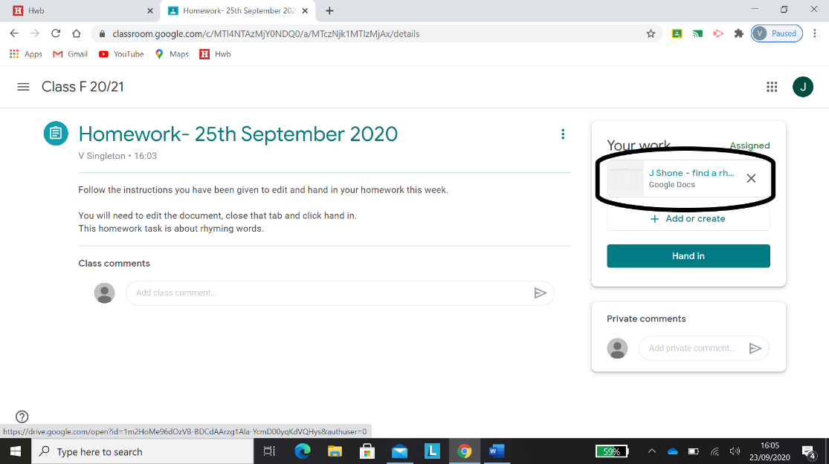 | 5. For this task, we have made a document that the children fill in. You click the circled document to open the template.
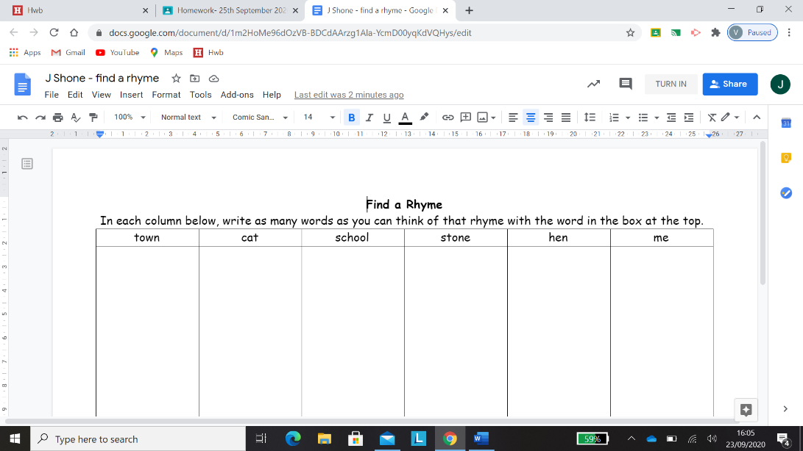 | 6. Now fill in the template as you would a normal word document.
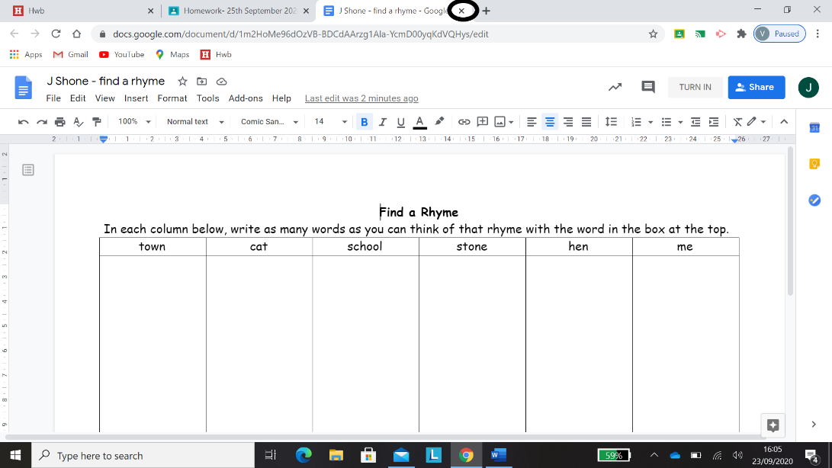 | 7. Close only the document tab you are working on by clicking the circled button (you do not need to press save as it will automatically save children’s work).
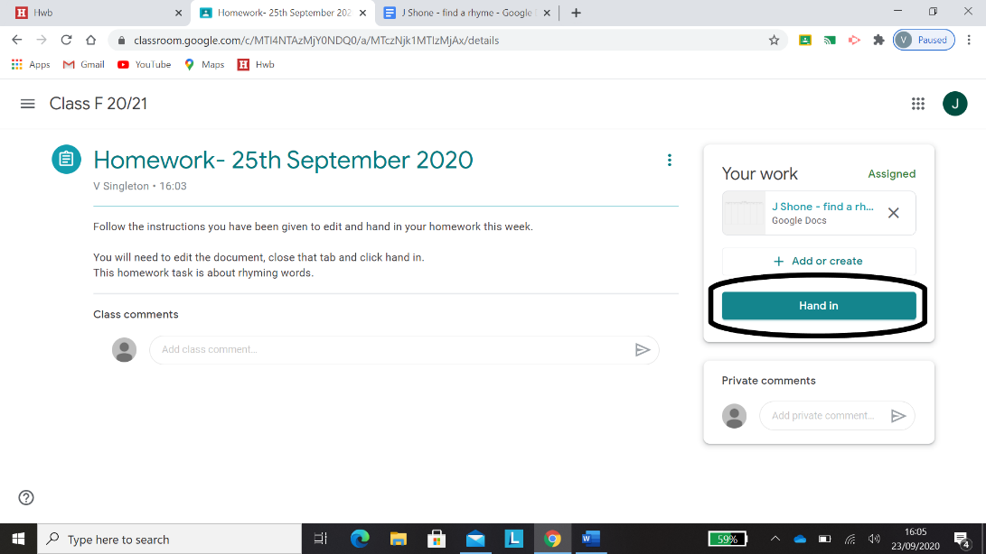 | 8. Then click Hand in, so that Miss Singleton can see your work.  Well done!

If you have any issues with the above steps please feel free to email me on SingletonV@hwbcymru.net or I can speak to anyone on the yard at the end of a school day.

