HOMEWORK GUIDE FOR PARENTS
Using a PDF and uploading a picture
Dear Parents/Carers,
The focus of the task this week is using a PDF as a worksheet, working on paper, taking a photograph of their work and uploading it to the Google Classroom. All children have been able to do this in school using iPads, but obviously the steps may be a little different depending on what the children use at home. If the children use laptops, we find it is then easier to use a mobile to take a photo of the work and upload directly from there- preferably though the ‘Google for Education’ App. If you use the app, the child will need to be logged into it using their own HWB email information.
- Your child will need to log into HWB and enter their details, then access their classroom via Google for Education
- Click on ‘Classwork’ and select the task needed. Click View Assignment.
- Click on the PDF to enlarge it. Your child can then complete the task on paper, you do not need to print.
- Next, get back to the assignment page. Click add or create
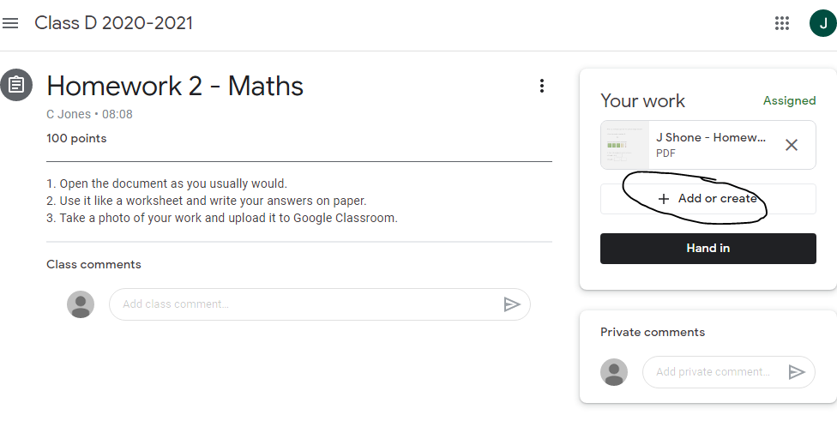
- Select- File
- Upload
- Browse
- Take photo
- Use the photo- you can retake the picture if you need to
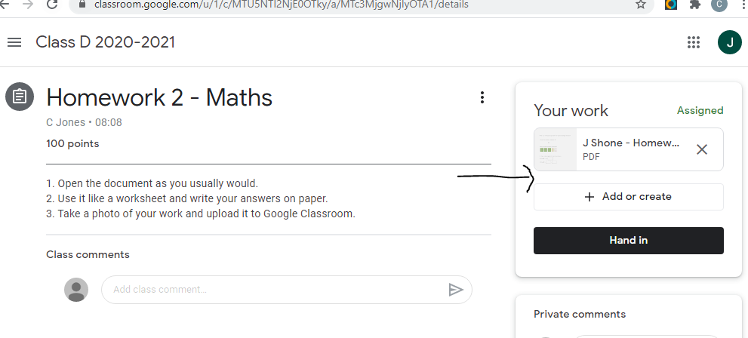
- Your picture will appear in the space indicated by the arrow.

- Then click ‘Hand in’ so that your teacher can see your work.

